Date Received: _____________

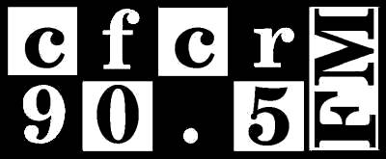

Name:
Address:
Postal Code: Phone number:
E-mail:

Please indicate the type of radio program you are interested in creating:
Specialty Music: Spoken Word:
Multicultural: Other:

Availability: Days of week
am pm

Thank you for your interest in becoming a VOLUNTEER HOST with CFCR. Please note that vacancies are rare; as such, only serious applicants will be considered and all applicants are subject to a probationary period as well as subsequent review by CFCR’s Programming Committee.

The probability of a proposal’s acceptance is based largely on originality and creativity. However, due to limited space in our programming schedule, we are unable at times to accommodate the large volume of new proposals we receive.

Please provide a detailed description of the program you would like to host. If your proposal is for a spoken word show, please indicate the main concepts for your program, as well as an idea of the type of format you would like your show to have. If your proposal is accepted for consideration you may be required to provide a demo tape. If you are proposing a new music program, please include the genres of music and/or themes you would like to focus on.

In this section, please list a minimum of twenty bands/artists that would make appearances on your show, or ten possible topics for programs you would like to broadcast. Please note that CFCR is a Non-Commercial radio station and, as such, is not permitted to broadcast much in the way of “Top 40” or “Hit/Commercial” music. If your proposal is for a Spoken Word show, please provide a list of program topics.

